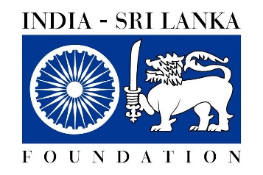

India Sri Lanka Foundation
Press Release
Invitation for Project proposals
The India - Sri Lanka Foundation (ISLF) was established by a Memorandum of Understanding between the governments of India and Sri Lanka in 1998 in order to foster India - Sri Lanka relations through the enhancement of economic, scientific, technical and cultural cooperation and to promote greater understanding between the people of the two countries.

India- Sri Lanka Foundation invites project proposals, in the areas of Art & Culture Education, Agriculture, Research, Science & Technology, Health, Social Works and Developmental Studies.

Under the above thrust areas, proposals could be submitted for research projects and other educational activities at recognised institutions of learning located in India and in Sri Lanka, visits and exchanges involving students, scholars, academics, artists, professionals and performing artistes, to participate in conference/seminar, symposia, art exhibition, film festival, cultural events and training workshops etc, publication of research works on India-Sri Lanka relations in the specified fields and translating literary works in Indian languages to Sri Lankan languages and publishing them, and vice-versa.

Individuals, institutions and groups are invited to submit proposals which would be considered during the next meeting of the Board of Directors of ISLF scheduled in April 2022.

A duly filled application form which could be downloaded from the High Commission of India website (www.hcicolombo.gov.in) along with the proposal may be e-mailed or forwarded to our address given below to reach us before 4th April 2022.

INDIA-SRI LANKA FOUNDATION
C/o. High Commission of India
36-38, Galle Road, Colombo 3
Phone: +94 11 2389924
E-mail: islfcolombo2@gmail.com

